Acquiring Visual Studio From Microsoft

**Steps:**

1. Go to the Azure for Education Site: <https://azureforeducation.microsoft.com/devtools>
2. Log in with your FIU student credentials.
3. **Scroll down** about ¾ of the page and select **Visual Studio Enterprise 2017** (which is what we have in our FIU labs – ***not 2019***):

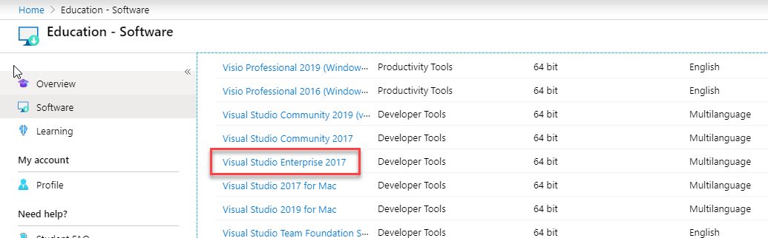

1. Click on that link, which will open up a panel on the right side. View your license key:

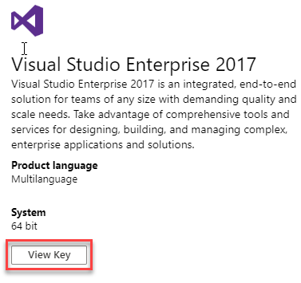

1. Copy and SAVE your license key:

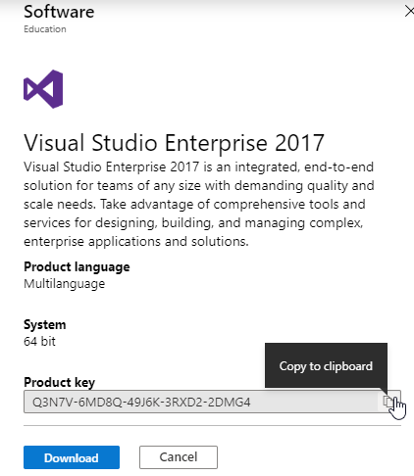

1. Then download. What you get is a launcher for the installation. Please note that the installation is a lengthy process – could easily be 45 minutes or more.
   1. Be sure to select .**NET Desktop Development** when you install Visual Studio.
   2. When you first start it, select Visual Basic as your profile/environment choice.
   3. Register your product with your license key as directed.